The Study of James: Contend for the Faith
Rescue the Wanderer - James 5:19-20

Directive to the Rescuer:
"19 My brothers, if anyone among you wanders from the truth and someone brings him back, 20 let him know that whoever brings back a sinner from his wandering will save his soul from death and will cover a multitude of sins." (James 5:19–20)

- Bring back the wanderer.

- Save the soul of the wanderer.

- Cover the sin of the wanderer.

Review of the Book of James:

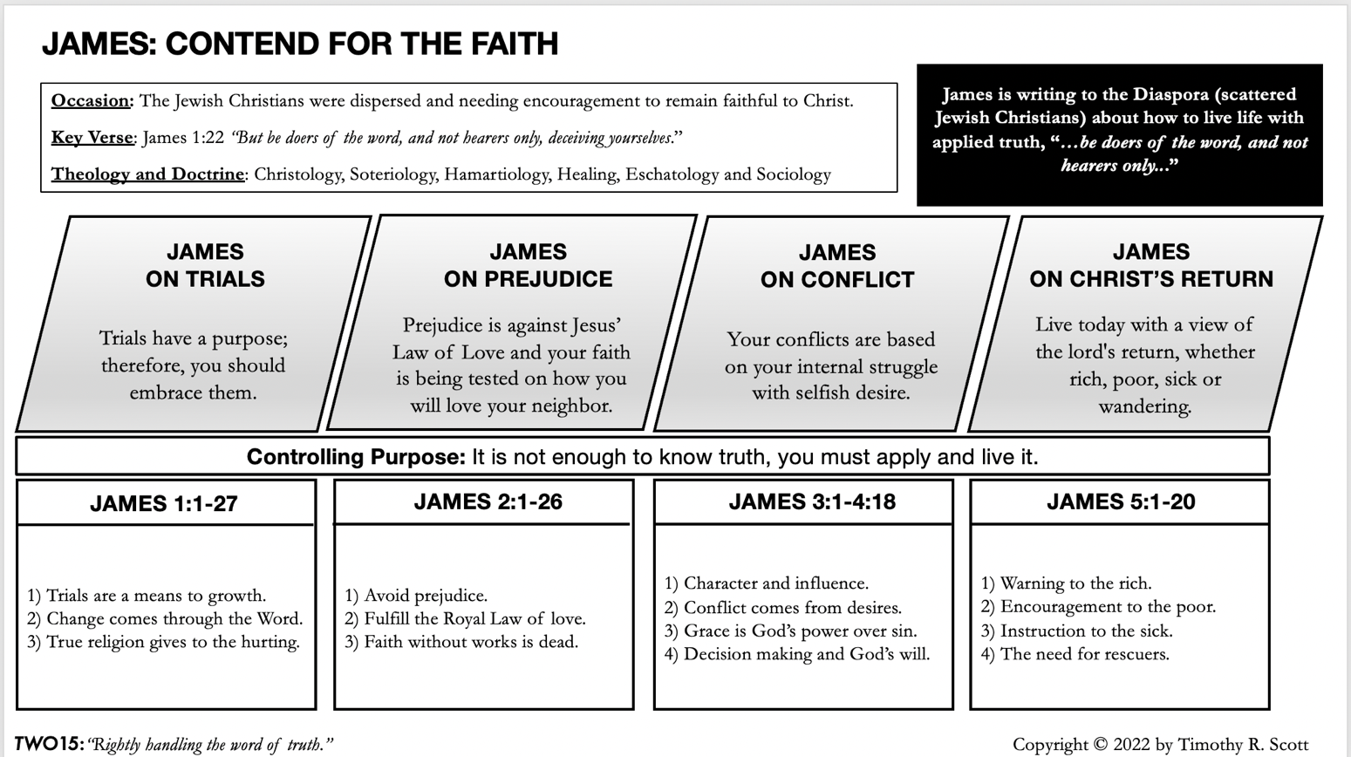

Discussion Questions:
- What is your attitude toward someone who wanders from the truth? What should your attitude be according to James 5:19-20?

- Discuss “will cover a multitude of sins” in James 5:19-20. Consider the difference between covering sin and enabling the sinner.

- Discuss with your group the highlights of what you have learned from the book of James.

