The Study of James: Contend for the Faith
The Life Cycle of Sin - James 1:13-15

Hermeneutics: Biblical Literalism and the Use of Metaphors.
The Grammatical-Historical hermeneutic acknowledges metaphors and other forms of figurative language in scripture.

James' Doctrine of Life
"Blessed is the man who remains steadfast under trial, for when he has stood the test he will receive the crown of life, which God has promised to those who love him." (James 1:12)

Crown of Life: The quality of life gifted by God to those who have been approved through trials.

James' Doctrine of Death
"13 Let no one say when he is tempted, "I am being tempted by God," for God cannot be tempted with evil, and he himself tempts no one. 14 But each person is tempted when he is lured and enticed by his own desire. 15 Then desire when it has conceived gives birth to sin, and sin when it is fully grown brings forth death." (James 1:13–15)

- Test and Temptation. (The same root word in the original language)

- The Three Lies of Sin.

- _____________________________________________
- _____________________________________________
- _____________________________________________

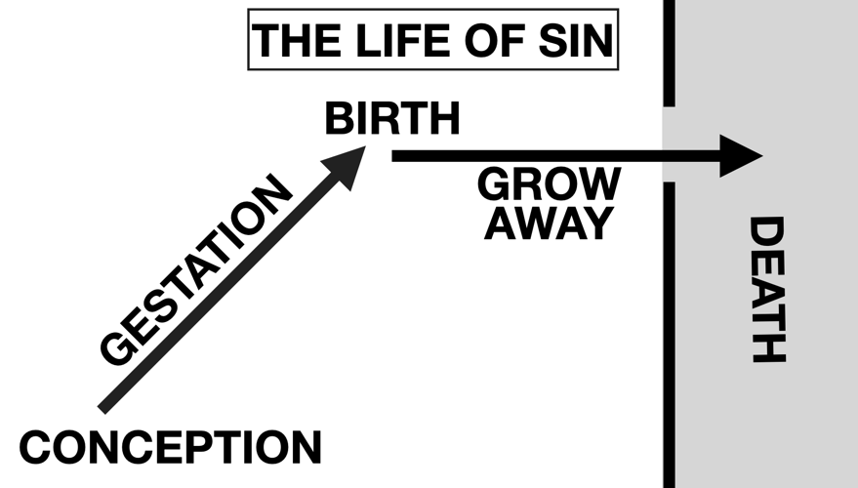
- The Life Cycle of Temptation.

Conception ______________________

Birth ___________________________

Grows away _____________________

Death __________________________

- We Choose Either Life or Death.

Discussion Questions:
- Discuss the three lies of sin. Share with your group how these lies have affected you.
- Discuss the life cycle of sin and how to avoid it, James 1:13-15.
- Discuss the difference between temptation and sin, James 1:14-15.

