The Study of James: Contend for the Faith
Wisdom in the Midst of Trials - James 1:5-8

Hermeneutics: The methodology of interpretation
Exegesis: The critical interpretation of a text, drawing out the text’s meaning.
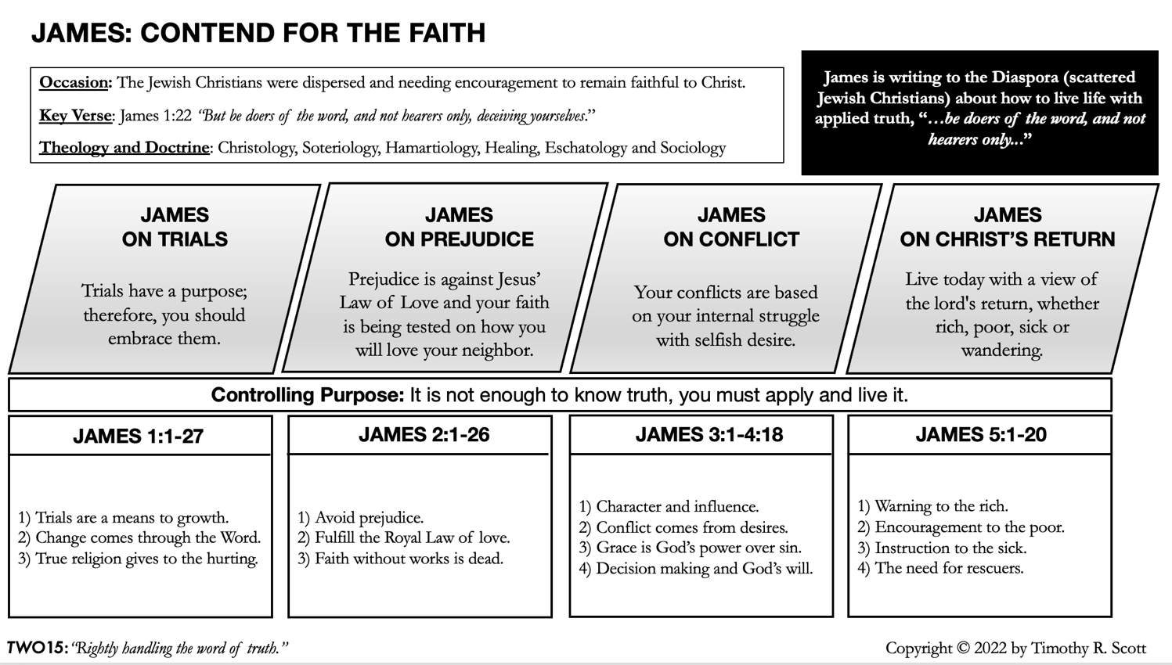
Expositional preaching: The presentation of the biblical text.

Wisdom is a Gift from God in Times of Trouble:
“5 If any of you lacks wisdom, let him ask God, who gives generously to all without reproach, and it will be given him.” (James 1:5)

Biblical Wisdom, Proverbs 1:20-33
- Wisdom is readily available to all. (V. 1:20-23)
- Wisdom will not wait forever. (V 1:24-32)
- Wisdom will produce security, ease of mind, and freedom of fear in trials. (V 1:23)
- Life without wisdom renders man subject to his “own devices.” (V 1:31)

James’ doctrine of wisdom, James 3:13-18
- Sourced in the Terrestrial: Worldly, Natural and Demonic. (Produces conflict)
- Sourced in Celestial: Divine. (Produces peace)

Faith is the Key to Subdue a Vacillating Life
“5 If any of you lacks wisdom, let him ask God, who gives generously to all without reproach, and it will be given him. 6 But let him ask in faith, with no doubting, for the one who doubts is like a wave of the sea that is driven and tossed by the wind. 7 For that person must not suppose that he will receive anything from the Lord; 8 he is a double-minded man, unstable in all his ways." James 1:6-8

- God promises wisdom in times of trouble.

How to resolve the conflict between the warning of Proverbs 1 and the promise of James 1:

"Then they will call upon me [wisdom], but I will not answer; they will seek me diligently but will not find me." Proverbs 1:28

"29 Because they hated knowledge and did not choose the fear of the LORD, 30 would have none of my counsel and despised all my reproof, 31 therefore they shall eat the fruit of their way, and have their fill of their own devices." Proverbs 1:29–31

Wisdom doesn’t make herself available to the foolish. It is wisdom in Proverbs 1 that is saying no, not God. In James, God is the one who responds to our prayer for wisdom.

- Faith requires the acceptance of God’s word as truth.

We must suspend our suspicious judgment and fully trust God.

Instrument Flight Rules versus Visual Flight Rules (Note: both are evidence-based)

- Doubt is described as a wavering indecisiveness, a “vacillating life.”
Double-minded ______________________________________________________

- Faithless instability.

Discussion Questions:
- How would you define wisdom?
- What is demonic wisdom, James 3:13-18?
- Discuss with your group how you value wisdom.
- Discuss the vacillating life, James 1:5-8.

